Features needed

Webclient:

1. 消息记录的保存与管理

我们的方案：目前有hipchat那种file保存。消息记录保存在本地user下默认文件夹里（Spark自动？）。

1. Hipchat: Files and Links，在界面上专门的tab下提示文件和链接，如图：

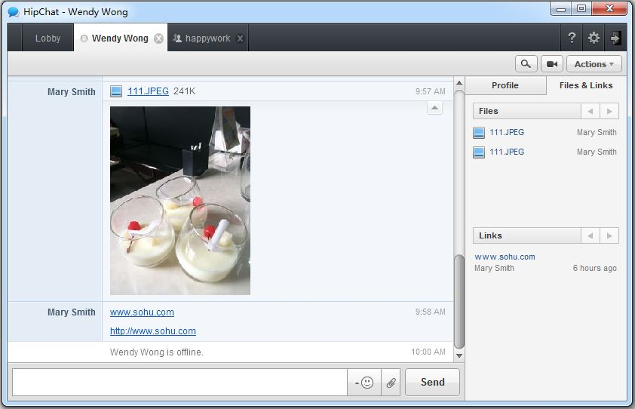

消息记录保存在网站专门的用户目录下：

例如：http://www.hipchat.com/history/member/382215

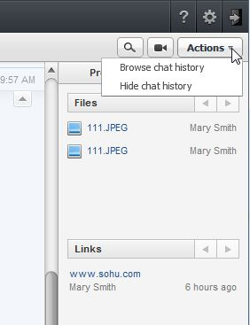

2）企业QQ：对话界面中有“对话记录”选项；

“显示对话记录”页面中，可以对当前对话历史记录进行导出、选择性删除、上传、查找和打印操作。

“记录管理器”中可以对指定对象的消息记录进行备份/还原、导出、查询、删除、上传等操作。

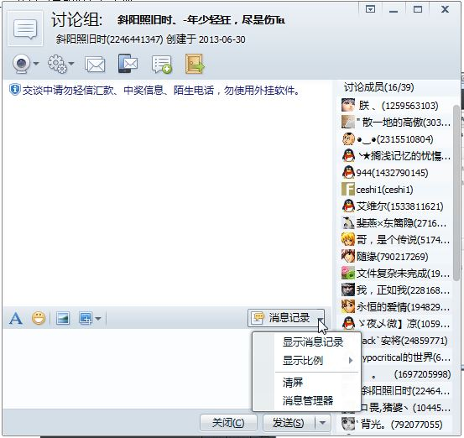

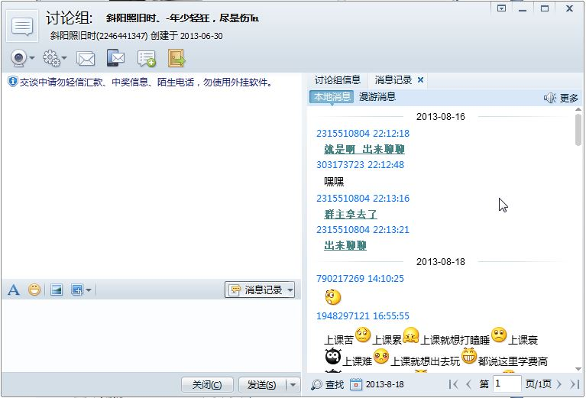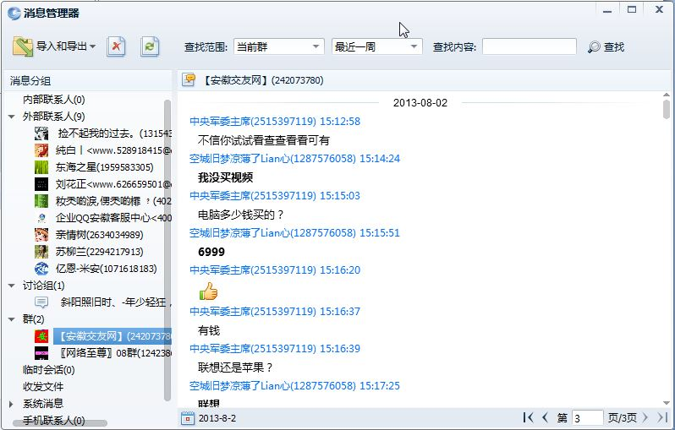

1. Qrcode apply to add friends
2. Actually I meant an online IM supporter in our product Like iPhone Sira or the imo Support. When a new user signs in and has no one to talk with, this online supporter can provide some simulative chat or even provide some help, such as useing everyday tip plus some greetings for auto chat content. It can also be a real support at worktime.

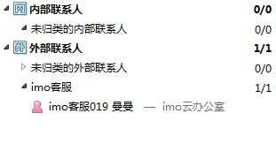

1. Tips of the day should be a float window not built-in a page.



1. Thanks for signing up letter.(uploaded to BCS-UX group).
2. Recent Activities🡪 Company Activities(2 schemes)
3. For webpage

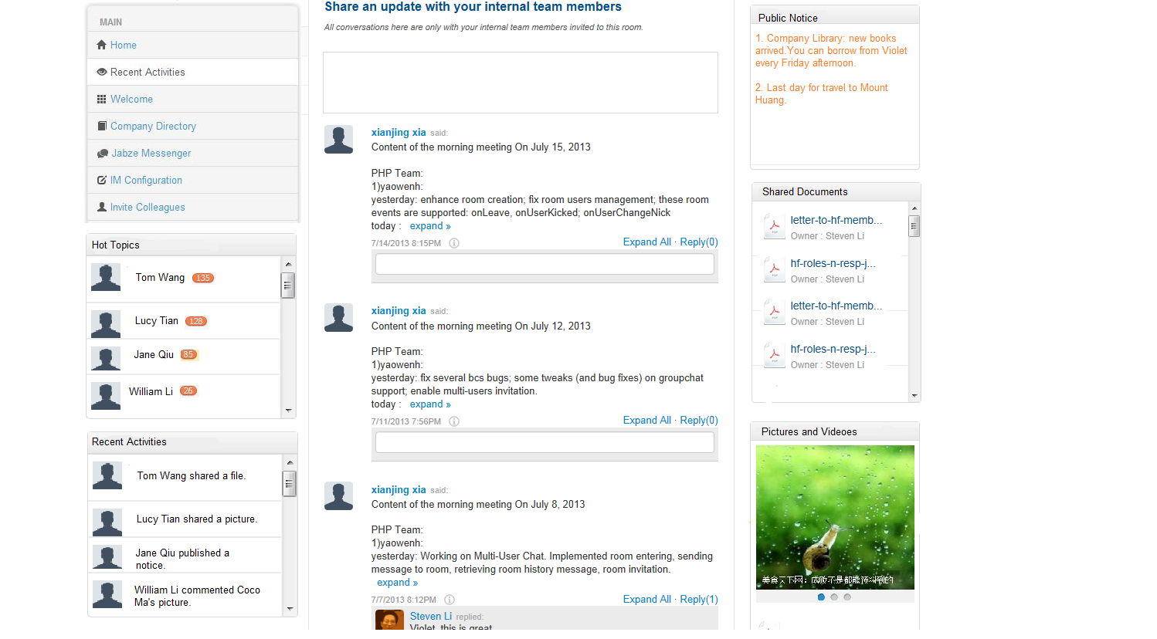

1. For messenger

